CMOS Ring Oscillator for On-Chip Clock Generation in SoC
A Project Based Learning Report Submitted in partial fulfilment of the requirements for the award of the degree

of

Bachelor of Technology
in The Department of Electronics and Communication Engineering
VLSI PHYSICAL DESIGN AUTOMATION: 23VLS3303A
VLSI SUBMICRON DESIGN AND VERIFICATION: 23SDEC18A

Submitted by
2310040040: D.Rahul
2310040042: K.Harshavardhan Reddy
2310040050: L.Bharat
2310049145: K.Raghuram
Under the guidance of
Dr. Kasi Bandla,Dr. K.Saikumar



Department of Electronics and Communication Engineering
Koneru Lakshmaiah Education Foundation, Aziz Nagar
Aziz Nagar – 500075
FEB - 2026.
Introduction
In modern digital systems, clock generation plays a crucial role in determining the performance, reliability, and efficiency of integrated circuits. A clock signal is required to synchronize operations across various functional blocks inside a System on Chip (SoC). Traditionally, external crystal oscillators are used to generate stable clock signals; however, they increase system cost, occupy additional board area, and limit integration flexibility. As a result, on-chip clock generation techniques have gained significant importance in VLSI design, especially for low-power and embedded applications.
A CMOS ring oscillator is one of the simplest and most widely used on-chip clock generators. It consists of an odd number of CMOS inverters connected in a closed loop. Due to the propagation delay of each inverter, the signal continuously toggles between logic high and logic low, producing a periodic oscillating waveform. The frequency of oscillation depends on the number of inverter stages and the delay introduced by each stage, making ring oscillators easy to design and integrate using standard CMOS technology.
This project focuses on the design and analysis of a CMOS ring oscillator for on-chip clock generation in SoC applications. To enhance practical usability, a capacitor bank is incorporated into the design to provide frequency tuning capability. By selectively enabling different capacitors, the load capacitance can be varied, thereby controlling the oscillation frequency. This approach closely resembles real-world clock tuning and calibration techniques used in modern SoCs.
The objective of this project is to understand the fundamental principles of oscillation, propagation delay, power consumption, and jitter in CMOS circuits. Through this work, the project demonstrates how a basic ring oscillator can be transformed into a tunable and practical on-chip clock source suitable for applications such as Built-In Self-Test (BIST), phase-locked loops (PLLs), and low-power embedded systems.
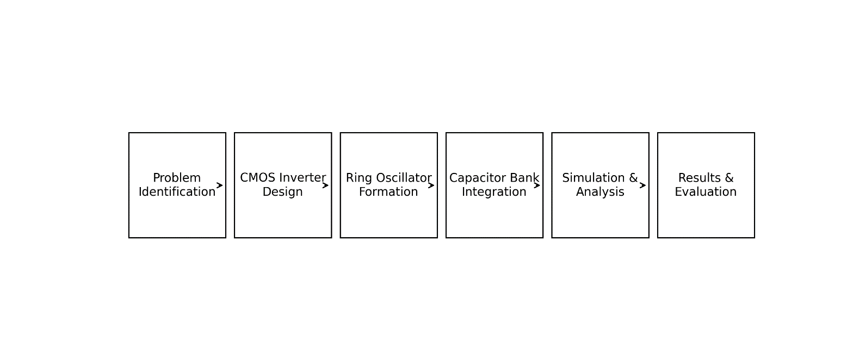

Literature Review/ Application Survey
Clock generation is a fundamental requirement in all digital and mixed-signal integrated circuits. Over the years, various oscillator architectures have been developed to meet different performance requirements such as frequency stability, power efficiency, and area optimization. Among these architectures, ring oscillators have gained widespread acceptance in VLSI systems due to their simplicity, ease of integration, and full compatibility with CMOS processes.
Early research on CMOS ring oscillators focused on understanding the relationship between inverter delay and oscillation frequency. Studies have shown that the oscillation frequency is inversely proportional to the number of inverter stages and their propagation delay. This relationship makes ring oscillators particularly useful for estimating process variations and device performance in fabricated chips. As a result, ring oscillators are commonly used as on-chip process monitors in modern semiconductor manufacturing.
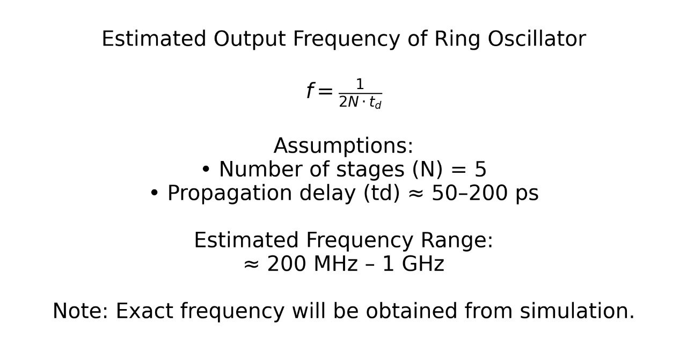
Several researchers have explored low-power ring oscillator designs for battery-operated and IoT devices. Reducing power consumption is critical in such systems, as the oscillator often operates continuously. Techniques such as transistor sizing optimization, supply voltage scaling, and current-starved ring oscillator architectures have been proposed to minimize dynamic and leakage power. These methods highlight the importance of balancing speed and power in oscillator design.
Another important area of research involves frequency tuning and calibration of ring oscillators. In practical SoC environments, variations in process, voltage, and temperature (PVT) can cause significant changes in oscillation frequency. To address this issue, programmable tuning techniques such as capacitor banks and digitally controlled delay elements have been introduced. Capacitor banks allow discrete tuning of frequency by adjusting the load capacitance, making them suitable for digital control and calibration circuits.
Ring oscillators also serve as the foundation for Voltage Controlled Oscillators (VCOs) used in Phase-Locked Loops (PLLs) and frequency synthesizers. In such systems, the oscillation frequency is controlled by a voltage or digital control signal to achieve synchronization with a reference clock. The simplicity of ring oscillator based VCOs makes them attractive for integration in high-speed and low-power clocking systems.
From an application perspective, ring oscillators are widely used in Built-In Self-Test (BIST) circuits, random number generators, temperature sensors, and on-chip timing references. In BIST architectures, an internal ring oscillator provides a self-contained clock source, enabling the chip to test itself without external equipment. Similarly, the inherent jitter and frequency variations of ring oscillators are exploited in true random number generation for hardware security applications.
In recent SoC designs, adaptive clocking techniques have become increasingly important. Ring oscillators with capacitor banks or digitally controlled tuning elements allow dynamic adjustment of clock frequency based on operating conditions. This adaptability improves energy efficiency and system reliability, especially in heterogeneous and multi-core SoC environments.
Based on the literature and application survey, it is evident that CMOS ring oscillators remain a vital component in modern VLSI systems. Their simplicity, scalability, and compatibility with advanced CMOS technologies make them suitable for a wide range of applications. The incorporation of a capacitor bank further enhances their practicality by enabling frequency tuning and calibration. This project builds upon these established concepts to design and analyze a CMOS ring oscillator suitable for on-chip clock generation in SoC applications, aligning academic learning with real-world industry practices.

References
- B. Razavi, Design of Integrated Circuits for Optical Communications, 2nd ed., McGraw-Hill, 2012.
- B. Razavi, CMOS VLSI Design: A Circuits and Systems Perspective, 4th ed., Pearson Education, 2015.
- J. M. Rabaey, A. Chandrakasan, and B. Nikolić, Digital Integrated Circuits: A Design Perspective, 2nd ed., Prentice Hall, 2003.
- P. E. Allen and D. R. Holberg, CMOS Analog Circuit Design, 2nd ed., Oxford University Press, 2002.
- A. Hajimiri and T. H. Lee, “A general theory of phase noise in electrical oscillators,” IEEE Journal of Solid-State Circuits, vol. 33, no. 2, pp. 179–194, Feb. 1998.
- J. Maneatis, “Low-jitter process-independent DLL and PLL based on self-biased techniques,” IEEE Journal of Solid-State Circuits, vol. 31, no. 11, pp. 1723–1732, Nov. 1996.
- M. Alioto, Energy-Quality Scalable Integrated Circuits for Low-Power Digital Signal Processing, Springer, 2011.
- N. Weste and D. Harris, CMOS VLSI Design: A Circuits and Systems Perspective, Pearson Education, 2011.
- S. Kang and Y. Leblebici, CMOS Digital Integrated Circuits: Analysis and Design, McGraw-Hill, 2003.
- IEEE Standard for Low-Power Clocking Techniques in SoC Designs, IEEE Std 1801, 2018.

